IT Services at The Alaska Club
The IT office and Main Server room is located on the second floor of the East Club. Standard office hours are 7:00 am to 5:00 pm.
After hours support is provided ON CALL via phone @244-4133. Please leave a message if no one answers. We will return your call as soon as we are able.
There are multiple ways to request IT services at TAC.
- Stop by the Office. We love visitors. Need a new mouse, scurry on over.
- Call the IT Support Line @4357. This rings all the desks in IT. If we’re here we will answer.
- Send the IT Staff an email. All IT Staff belong to group AKCIT@TheAlaskaClub.com.
- Open a Work Order on LanSweeper. See directions below.
- Send an Email to HELPDESK@theAlaskaClub.com. This will create a LanSweeper Work Order.
- After Hours ON CALL via phone @244-4133.

Open a Work Order Request – “The Easy Way”
Simply send an email to Helpdesk@thealaskaclub.com. This will open a LanSweeper work order. The Subject of the Email will be the Subject of the Ticket Request. You will receive a response from the system once the ticket is opened. It may take several minutes to open a ticket and generate a response.
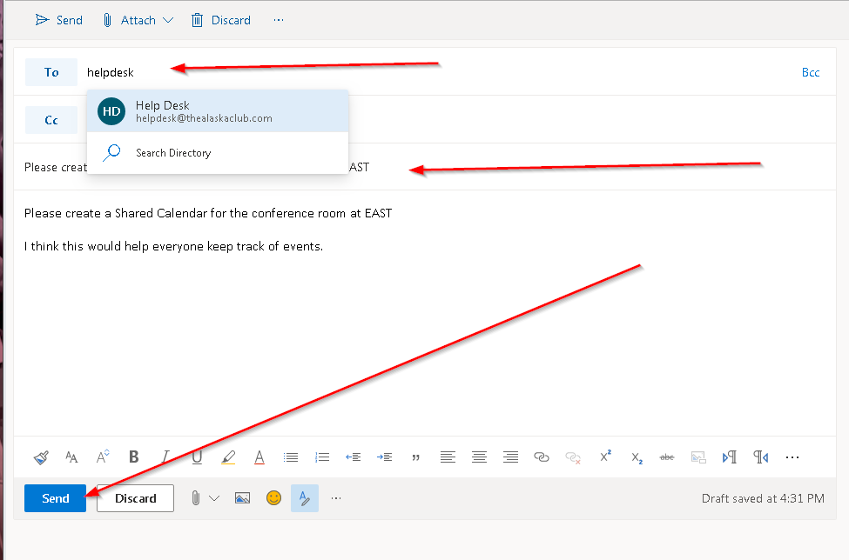

LanSweeper Work Order Tracking Program
At TAC we use LanSweeper Helpdesk to document, track and manage IT work requests. Any person with an AlaskaClub Email account can submit a work request to the Helpdesk program. If you don’t have email at TAC please refer to the alternative ways to request IT services.

The program can be accessed via the web at http://svr-update.thealaskaclub.com:81/helpdesk/.
You do not have to log onto the site to use LanSweeper. Sending send an email to helpdesk@thealaskaclub.com will open a LanSweeper Ticket. Tickets can be Updated and Reopened if needed via email.

Logon
Using your Windows credential.
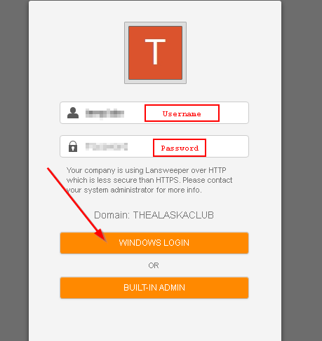

The LanSweeper Work Order Dashboard
Open a new Ticket;
Review or edit an existing Ticket;
Review and reopen closed Tickets.
Select GO To Ticket if you have a specific ticket number.
Additional Features will be available in the future.

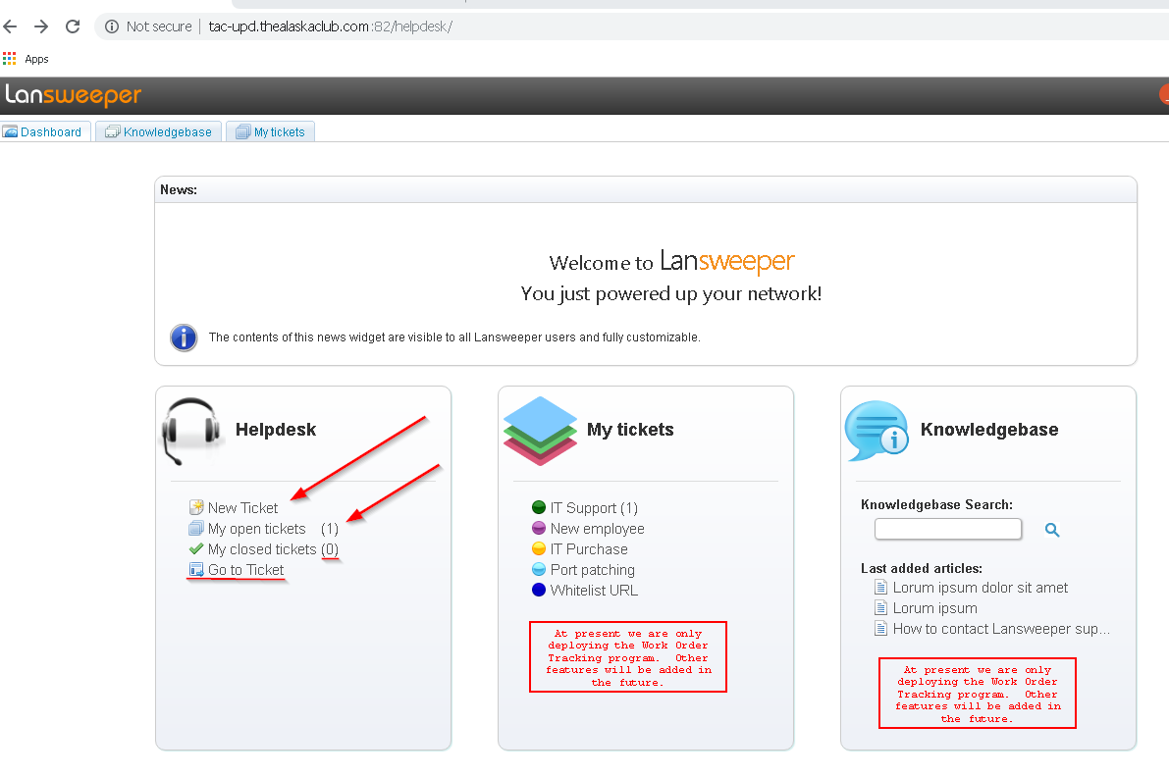

Selecting New Ticket: Will bring up the Wizard. The Subject will be the main request of the Ticket. Subject and the Body text are required. Add attachments and screen shots if desired. The other fields are not used presently.

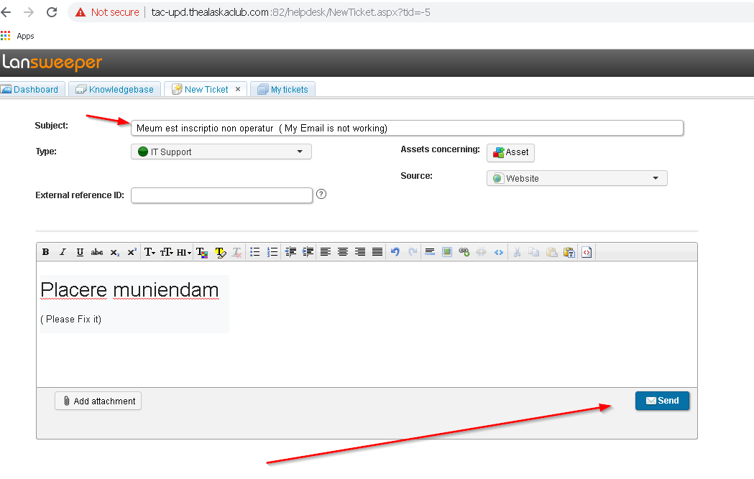
Selecting Open / Closed Ticket: from the Dashboard will take you to the same screen with options preselected. To edit or view a ticket, click on the BOLD Subject, an the edit ticket screen will open. Change the selection options to see closed tickets.

